Where Would He Be Without Esme

An Occasional Series

30 October 2016

Once maybe every month or so, just to keep her C on his toes, Esme takes an opportunity to demonstrate that even her excellent training by Theophainia Brassard is no match for the full measure of her fun-loving nature.

Good old C had been scratching his head about that half loaf of bread. He just couldn't remember finishing it. There would have been one final sandwich with the crusty end slice.

This morning, to give her C a good tickle on a dreary Sunday, Esme dug it up from out back and deposited it, covered in dirt, on his bed.

What was that word her C used when he saw it? What was that intonation? Esme can understand words and intonations.

20 February 2016

Esme is excited to announce, through her C, that at this young age she's begun writing her memoir.

Working title: Eat. Smell. Get petted.

Esme's looking for advances, all of her C's FB friends should know.

11 February 2016

WHAT in heaven’s name does her C have his blue jeans all wadded up about now, thinks Esme. Can’t be that debate on TV; his guy did great. Can’t be that doggie and doggie owner kerfuffle; that was put to bed in right ways.

He’s upset about the mattress cover thingee?

That new mattress cover that her C bought just this morning smelled weird. That new mattress cover was chewable; he’s complaining that it got chewed into oblivion? Heck, he got 20% off at Bed Bath and Beyond for that weird mattress cover.

Why didn’t her C just get it together and make the bed?

25 January 2016

Uh oh, Esme is thinking. Uh oh, this fellow Jorge, the one with legal and financial responsibility for Daisy the dog who beat Esme up, this Jorge seems to have gotten her C upset. Ethical this, unethical that, her C just keeps muttering stuff about ethics. And what does "wage a social media campaign to shame Jorge into fulfilling his legal and financial responsibilities" mean? Whatever, Esme knows her C would never do anything unethical. But he does seem annoyed. She's never seen him like this. Well, there was that one time when she ate the sheets right off his bed.

24 January 2016

Well, one place Esme's C wouldn't be is at the emergency vet hospital from 1 to 11 PM on a Saturday, following an attack by another dog at the dog park that ripped open Esme's lower right eyelid. Esme is on the mend and her C is learning just how ethical other dog owners are about recompense.

15 November 2015

Back to the dog park! Endless possibilities for Esme's C to interact socially.

Esme saunters over to that blonde woman who is so deeply in conversation with that guy. Esme sniffs a bit, then pees on the woman's foot.

Esme's C is mortified! He's now worrying that Esme is unclear on the concept of "Wingman."

Esme's thinking her C can do a lot better than that blonde.

7 November 2015

Esme, C's owner, figures she had C at her colors.
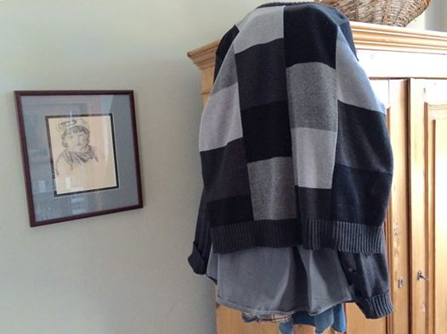

5 November 2015

What's with this guy C, C's master, Esme, puzzles. He's got some unconscious death wish or something about his food and her instinctual need for same?

He brings home a pound of sliced, free-range Black Forest Ham to make ham and cheese sandwiches, and as he eats his two sandwiches, just maybe a yard around the corner, he has neglected to wrap up and put in the fridge the rest of the pound of sliced free-range Black Forest Ham?

What, he's thinking ahead for the convenience when he makes a third sandwich? He's never eaten three. Clearly, Esme thinks, this guy is not thinking at all as he falls asleep in front of the Warriors game.

Weird. Don't get it wrong she's quite fond of this guy C. But weird.

28 October 2015

Because he is being such a great guy, Esme gives C a whole Saturday to himself: tennis, brunch with his tennis partner, watching college football at his pub. Esme figures that C will feel so guilty about leaving her for so long alone that upon his return home he'll shower her with affection, and this in fact happens.

Esme sits on C's lap and looks so long and hard into C's eyes that it puts him in mind of when his daughter was a babe in arms and couldn't yet speak; she looked up at him, straight in the eyes, in just this way. He could see the wheels turning inside her head, just like now with these wheels inside Esme's head.

C thinks this is such a profound and clever insight that he goes into his office to write it down in his journal. It takes him a minute to do this, just enough time for Esme to eat the second six inches of C's footlong sub.

25 October 2015

C's owner, For Esme--With Love And Squalor (Esme), is not aka Shadow Underfoot for no good reason. With her around the house, C is put to mind of the old high school cheer: Lean to the left! Lean to the right! Stand up, sit down, fight, fight, fight!

C is reminded of this cheer because when he leans to the left, Esme leans to the left. When he leans to the right, Esme leans to the right. When he stands up, when he sits down--you get the picture.

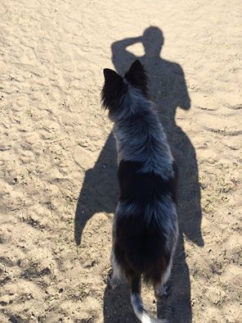

23 October 2015 (Tessa McGarvey’s birthday!)

To improve his social skills, Esme takes C to the Alameda Dog Park. And it seems to work! C begins chuckling it up with two not at all unattractive women. (Good boy, C! You go, C!)

C's saying how the dog park is just like the bar scene in Star Wars. The women say, the people or the dogs, haha!

Suddenly, Esme is in receipt of an affront so egregious from one of the women's dogs that she, Esme, is forced to defend herself vigorously. C, foolhardy friend that he is, reaches in to end the kerfuffle, and one of the women throws her Starbucks coffee at the entanglement, showering not her dog, not Esme, but C, all over his jacket and jeans.

Esme takes him home to change, assuring him that not every venture into social interaction will end this way for him. Good boy, C. You go, C.

15 October 2015

Sunday, 11 October 2015 (last day for which full data is available).
Owned-by-Esme guy, we'll call him C, gets up real early and takes Esme to the beach for a run. C then goes to play tennis with Ms. Paige Ivey. (Don't ask C the score.) After two sets, C and MPI stop by house before breakfast to check on Esme; she's good; she's done nothing bad.
C and MPI eat breakfast, go to the pub and watch the first NFL games. C goes home to find his bedspread spread out on the floor. C scolds Esme, who knows now to hide under the bed in second bedroom during scoldings. C showers and, still steamed, banishes Esme to the back yard. C is certain he has locked the gate (Esme sauntered out twice during her first week of owning C).
C goes back up to the pub to watch the Niners (such a great game, and C is thankful he no longer cares enough about the Niners to feel bad about loss). C drives home after flirting with the gals after watching the game. C parks on the street in front of his house. C opens the car door. Esme is there on the street by the car and jumps into his lap. ! C is ever a step behind.
Poor poor C.

1 October 2015

Mugshot and Prosecution Exhibit A, The State v. For Esme--With Love and Squalor, aka Esme, aka Shadow Underfoot, aka Havoc Wreaker, aka Gallop Glorious, aka Bites Off Her Lovely Nose to Spite Her Beautiful Face, aka No Doghouse Too Harsh, aka Little Ms. Obstreperous, aka Tantrum Terrible (French pronunciation), aka Miss Catastrophe, aka & Throw Away the Key.

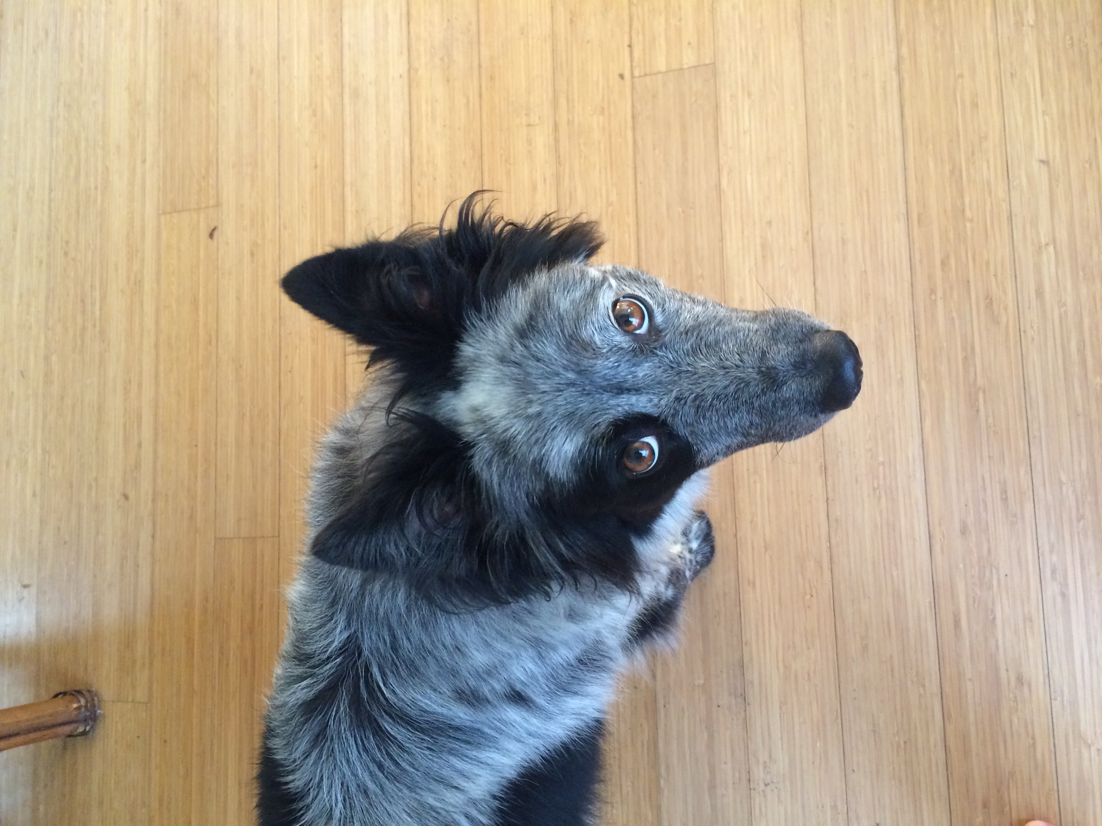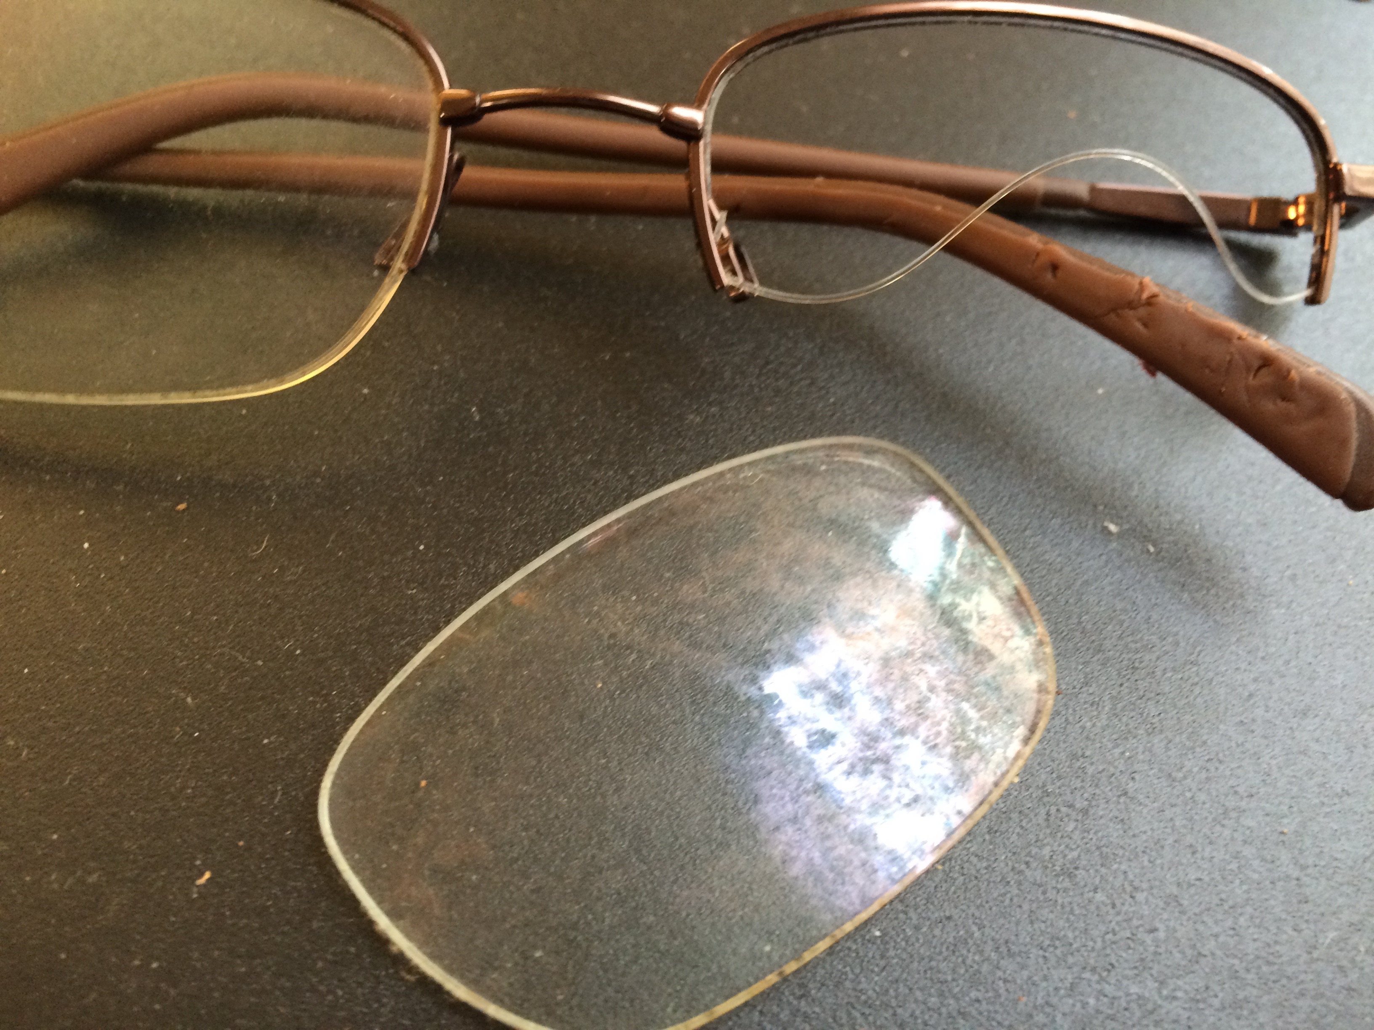

9 August 2015

